Ex. No.: 8

Date:

**Query with SubQuery & Correlated Query**

**AIM:**

To perform subquery and correlated query on the given relations.

**DESCRIPTION**:

**SUBQUERY**

A MySQL subquery is a query nested within another query such as SELECT, INSERT, UPDATE or DELETE. In addition, a MySQL subquery can be nested inside another subquery.

A MySQL subquery is called an inner query while the query that contains the subquery is called an outer query. A subquery can be used anywhere that expression is used and must be closed in parentheses.

**CORRELATED QUERY:**

A correlated subquery is a subquery that uses the data from the outer query. In other words, a correlated subquery depends on the outer query. A correlated subquery is evaluated once for each row in the outer query.

**SYNTAX**:

**SUBQUERY:**

**SELECT** c1, c2,...,cn

**FROM** table

**WHERE** c1 IN (SELECT c1, c2,...,cn

FROM table

WHERE where_conditions);

**CORRELATED QUERY:**

SELECT *

FROM table_name

WHERE EXISTS(subquery );

**Questions**:

**Sub-Query and Correlated Sub-Query:**

1. Which of the student’s score is greater than the average score?
2. Which of the students’ have written more than one assessment test?
3. Which faculty has joined recently and when?
4. List the course and score of assessments that have the value more than the average score each Course

**OUTPUTS:**

1) Which of the student’s score is greater than the avg score?

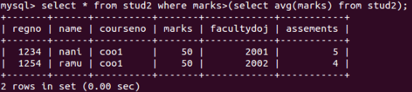

2) Which of the students’ have written more than one assessment test?

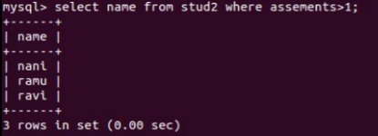

3) Which faculty has joined recently and when?

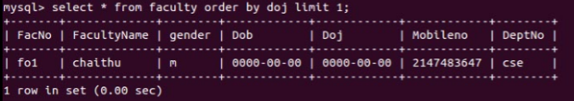

4) List the course and score of assessments that have the value more than the average score each Course

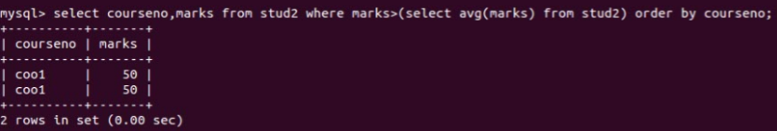

**RESULT**:

The records from the tables are displayed using Sub-Query and Correlated Sub-Query.